In second order filter output ringing noise can be heard in background, this type of noise is not audible in output of audio output of fourth order filter.

Pole Zero plot

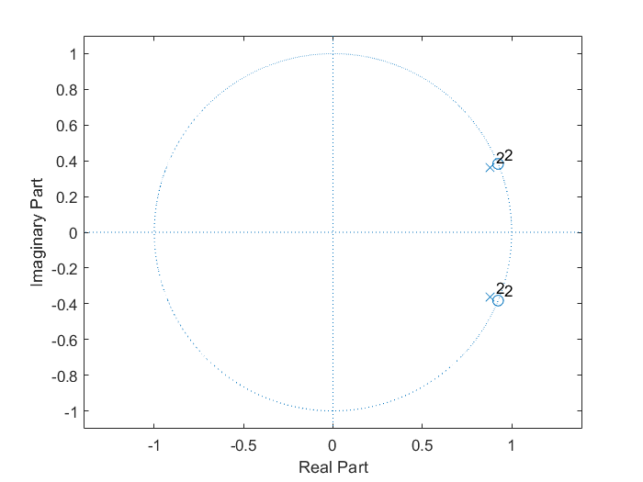

Impulse Response

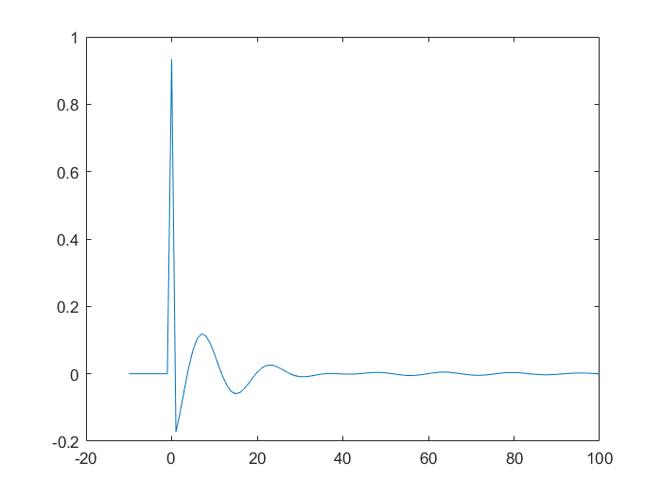

Frequency Response

